Tourist rail excursions took shape in Southern California

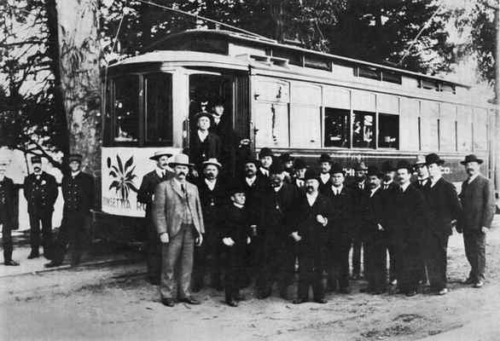
The San Bernardino Valley Traction Company’s Poinsettia Route excursion car about to begin its maiden excursion voyage, on January 30, 1906, at Urbita Springs. The Poinsettia Route flower symbol can be seen on the front of the car. (Courtesy photo)
By Mark Landis, San Bernardino County Sun
POSTED: 05/08/17, 8:48 PM PDT | UPDATED: ON 05/08/2017
0 COMMENTS

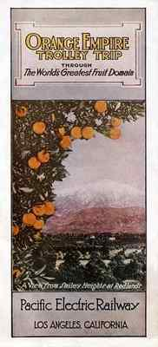
Pacific Electric brochure for the Orange Empire Trolley Trip from circa 1915. This tourist excursion was made possible by the completion of the Pacific Electric’s line between Los Angeles and San Bernardino in 1914. (Courtesy of Mark Landis)

Beginning in the late 1800s, Southern California became a mecca for tourists, and the local railroads created tourist excursions that highlighted the region’s beautiful scenery, delightful new towns and unique local attractions.
Many of the routes promoted the expansive orange groves and bustling citrus towns of the Inland Empire as highlights of the excursion.
To draw new passengers, the railroads gave their tourist lines alluring names and catchy slogans that were designed to pique the rider’s interest and evoke vivid images of the trip. Some of the excursions were even named after shapes that the route resembled, such as The Balloon Route, The Kite-Shaped Track, and The Poinsettia Route.

Santa Fe’s “Kite-Shaped Track Excursion” operated from 1892 to around 1917.
The railroad promoted the line with memorable advertising slogans like “No scene Twice Seen” and “Done in a Day.”
The 166-mile route formed a huge figure-eight that laid horizontally across Southern California from Los Angeles to the San Bernardino Valley. The “kite” name came from the popular figure-eight shaped horse racing tracks of the era known as “kite-shaped tracks.”
Passengers could board the train in Los Angeles at 8:30 am, and begin their excursion through the orchards and foothills of the San Gabriel, Pomona, and San Bernardino valleys.

The apex of the figure-eight was at San Bernardino, and smaller “Eastern Loop” wrapped around the San Bernardino Valley. Extended stops in the towns of Pasadena, Redlands and Riverside allowed passengers to disembark and tour the orange groves and see the mansions of the wealthy easterners who had built their summer homes in the burgeoning new communities.
The return route ran southwest through Riverside, Corona, the Santa Ana River Canyon and into Orange County. Looping west and north through Fullerton and Los Nietos, the full excursion was completed back in Los Angeles at 6:10 p.m.

The Mount Lowe Railway operated as a tourist excursion from 1893 to 1938 and called itself “The Earth’s Grandest Mountain Railway.”
This famous mountain railway was built in 1893 by Thaddeus Lowe, a wealthy east coast entrepreneur and a brilliant inventor. Lowe moved to Southern California in 1888 and teamed up with engineer David Macpherson to build the world’s first scenic mountain electric railroad.

The Mount Lowe Railway was an engineering masterpiece that took advantage of the rugged mountain scenery above Pasadena and the proximity to a large population center. In a clever marketing scheme, the builders gave the line’s unique features alluring names that evoked images of a mountain adventure.
The line began fittingly at Mountain Junction, which was located at the present-day site of Lake Avenue and Calavaras Street in Altadena. The lower section of the line was named The Mountain Division, and it climbed the foothills into Rubio Canyon and ended at Rubio Pavilion. The 12-room pavilion hotel was tucked neatly into a notch in the canyon and served as the transfer point to the line’s most distinctive feature, The Great Incline.
The Great Incline was an engineering marvel that used a pair of “funicular” passenger cars to climb and descend a cable-driven incline railway that gained 1,300 feet of elevation over a distance of 3,000 feet. The incline terminated at Echo Mountain, where the facilities included a grand hotel, a large chalet, a spacious dance hall, an observatory, a zoo, repair shops and a power house.

From the Great Incline, passengers boarded the cars of the Alpine Division, a 3.5-mile route that wound its way through hair-pin curves, over lofty trestles, and through notches blasted from the rocky cliffs. The trolley cars passed through extraordinary topographic and man-made features with names like “Granite Gate,” “Sentinel Rock,” “Circular Bridge,” and “Horseshoe Curve.”
The line terminated at the Alpine Tavern where guests could enjoy a day of hiking or sightseeing, or stay overnight in a comfortable hotel room or tent-cottage. Guests could also enjoy tennis courts, miniature golf, a fox farm, and meandering trails to vista points.

In 1902, Henry Huntington’s Pacific Electric Railway purchased the Mount Lowe line, and made major investments and upgrades to the facilities. The line survived numerous wildfires and floods, as well as the great depression, but it could not withstand the great flood of 1938. The massive downpour devastated the facilities and forced the final closing and abandonment of the line.
Southern Pacific’s “Inside Track” excursion operated from 1902 to 1915, and was a direct competitor to the Kite-Shaped Track excursion. The route of the Inside Track traveled east from Los Angeles, and offered similar excursion features such as a trip through the orange groves, and stops in Redlands and Riverside.

The San Bernardino Valley Traction Co.’s “Poinsettia Route” tourist excursion operated for only one year in 1906. The Traction Company used their existing electric trolley lines to carry passengers through some of the scenic areas of the San Bernardino Valley. The destinations of Colton, Baseline, Highland, Redlands, and Urbita Springs were at the tips of this “poinsettia-shaped” route, and San Bernardino was at the center of the flower. The line suffered from low ridership, and the special-order excursion car was reassigned to other routes.

The Pacific Electric’s “Orange Empire Trolley Trip” operated from 1914 to 1929, and was largely responsible for the demise of the other local steam train excursions. The electric cars traveled through similar countryside, and could operate more efficiently than their steam rivals.
The Orange Empire line ran from Los Angeles east to Rialto and Bloomington, and turned south to Riverside. After a stop at the Mission Inn, the excursion traveled through the citrus groves into the San Bernardino Valley, and stopped at Redlands, where passengers could disembark and tour Smiley Heights.

Pacific Electric’s famed “Balloon Route” tourist excursion operated from 1901 to the mid-1920’s. The electric trolley line traveled northeast from Santa Monica to Beverly Hills, and looped around Hollywood and Los Angeles, before returning to Santa Monica. The line then turned south, and ran through several beach communities. Extensive advertising materials and clever slogans like “not up in the air – but best on earth” and “101 miles of sightseeing for 100 cents,” kept the Balloon Route popular for decades.

Some of the routes used by the excursion rail lines are still in use for freight and passenger service, but most of them are now buried beneath concrete and pavement. Thanks to the extensive photos taken by tourists, and the wonderful advertising materials, these excursions live on as cherished memories and an important piece of our history.

Mark Landis is a freelance writer for The Sun. He can be reached at: Historyinca@yahoo.com.

